CIM Steady-State Solution Interfaces
Technical Note

Requirements

Summary of Use Cases

A variety of use cases have been developed that require exchange of solved power flow or state estimator results:

- Exchange of network models. EMS A and B are neighbors in an interconnection and therefore each needs to represent the other as part of its external model. The best way to do this is that they both send each other representations of their internal network model. Typically this would be an exchange between the modeling applications rather than the real-time EMS. Scope is limited to network data and measurement placements. (This is the use case that drove the 61970-452 standard.)
- Common Modeling Source. Within an EMS installation, there is typically a model management off-line function that supplies models to the on-line EMS. But other business systems, like planning or market management, also need models. An enterprise goal will be to have a common source so that data does not need to be entered multiple times. Since systems from different vendors may be involved, standard interfaces from a modeling source to various target environments is desirable. The different targets have some important differences in the level of input required.
  - An EMS requires a model that covers any point in time, and thus data (like load or target voltages) that vary over time are specified in terms of schedules.
  - A planning power flow requires data for a specific “case”, which is either one real point in time or one hypothetical point in time – like a coincident peak load for a season.
- Exchange of solved cases. Several flavors…
  - Real-time exchange among different applications. For example, state estimator solution used to initialize contingency analysis, market analysis, dynamic analysis.
  - Real-time cases to study. From time to time power systems get into situations that need to be analyzed by engineers. It is desirable that solved state estimator cases saved in real time can be exported to analytical tools, including planning applications. The engineers will want the estimator results as well as the input data. Some special attributes exist here, such as the desire to preserve bus naming to match planning conventions.
  - Exchange of study cases between different tools. Numerous examples, sometimes between same kind of tool from different vendors and sometimes from one kind of tool to another.
  - Import of study cases to EMS. Not many examples today, but will occur as near-term operations planning communicates back to EMS in a more integrated way. UCTE Day-ahead is a potential example.
- UCTE Day-Ahead. Western Europe security practice in which study cases are generated for the next day by each TSO representing the expected state of their internal network. Cases are exchanged and each TSO has the additional responsibility of constructing regional models and analyzing network congestion in their territories.

Requirements Analysis

When we look across this set of use cases, we can find a number of groups of data that will be helpful to talk about separately.

- Equipment. This identifies equipment and describes basic characteristics.
- Connectivity. Describes electrical connectivity that would be input to topology processing.
- Schedules. Describes input to functions that derive parameters for a specific point in time.
- Status. The state of switches – input to topology processing.
- Topology. The result of topology processing. i.e. Description of how equipment connects into buses and how buses makeup connected systems.
- Scheduled. This is the result of time scheduling to develop input for a case.
- Analogs. The set of SCADA values for analog measurements for a particular point in time.
- State. This is the set of state variables used in the mathematical formulation that the algorithms work with.

In an EMS environment:

- A modeler supplies Equipment + Connectivity + Schedules to the EMS.
- The EMS code develops Topology + Scheduled data for the desired case.
- Manual override of the Topology + Scheduled result is allowed.
- Scheduled data plus local directives are used to initialize State.
- Algorithm develops solved State.

In a planning environment, typical applications start with a “case”, that is Equipment + Topology + Scheduled (where Topology and Scheduled data is manually entered or obtained by a different means that it is in an EMS). This basically says that you start with EMS step 3.

Both environments feed the same case data (Equipment + Topology + Scheduled) into their solution applications and both arrive at the same endpoint, generating the solved State data in the same form.

The key question in the design of standards is how to address the different starting points. To date, partially because the 61970-452 standard is the only thing we have to work with, the use cases that begin with Topology + Scheduled data need to reverse engineer Connectivity and Schedules to come into compatibility with 452. This can be made to work, but the resulting schedules are not realistic, and it’s basically extra work and extra data.

We know that we need a standard for exchanging solved cases. The use cases for receivers of solved cases from state estimation often require that the receiver is able to completely recreate the case input. Since there is normally the possibility of manual override of data, cases cannot simply be recreated from 452 data. In other words, this means we need to define exchange of Topology + Scheduled data as well as State.

If we need to exchange Topology + Scheduled anyway, then it makes sense to set up the family of profiles so that use cases may bypass Connectivity and Schedules where that makes sense. The profiles proposed in the following sections try to achieve this result.

Static Model Exchange (61970-452)

Equipment + [Connectivity] + [Schedule]

The following changes should be made to the 61970-452 profile:

- Connectivity data should be optional. This includes the ConnectivityNode class and the association between ConnectivityNode and Terminal.
- Schedule data should be optional.

Notes:

- In state estimator usage, it is important for the Equipment model to include status and analog measurement definitions that are to be obtained from SCADA sources.

Questions:

- Are bus name markers part of the optional Connectivity data? The bus name markers are static input data used as input to rules used by topology processing that create TopologicalNodes with names.

Case Input Exchange

Ref(static model) + Topology + Scheduled

Case input exchange refers to a static model instance, and includes all the data required to define a “case” (one steady-state instance) that is not already available in Equipment data.

Topology data includes:

- TopologicalNode objects with associations directly to Terminals. This allows the electrical structure of the network to be understood from Equipment and Topology without any use of ConnectivityNodes.
- TopologicalNode objects may have names. The source of these names could either be manual entry or computed by topology processing based upon bus name markers and various rules.
- Breakers are allowed in this model, but if they appear, the meaning is that these are to be retained as branches in network analysis, with flows calculated in the output.
- TopologyNodes are grouped into TopologyIslands, which are groups of connected buses that should be solved with a separated voltage angle reference.

Scheduled data includes:

- At topology nodes:
  - Operating voltage limits for warnings?
  - Or should voltage operational limits be on voltage levels?
- At generators:
  - MW and MW limits.
  - MVAR or MVAR limits.
  - Voltage regulation target value, location, deadbands, etc.
- At loads:
  - MW, MVAR
- At capacitor banks:
  - Continuous variable and reactive limits, or discrete reactive values.
  - Voltage regulation target value, location, deadbands, etc.
- At transformer taps:
  - Continuous voltage tap and tap limits, or discrete tap positions.
  - Voltage regulation target value, location, deadbands, etc.
  - Continuous phase angle shift and limits, or discrete tap positions.
  - Flow regulation target value for flow control, deadbands, etc.
- At branches:
  - Limits
- At DC converters:
  - Control specifications.
- At TopologyIslands:
  - Reference angle location and value.
- At control areas:
  - Net interchange.
  - Slack specification. What exactly is this? Is this the Boolean for whether or not the area interchange is being enforced?
  - Tie points. This could likely be derived from static model.
  - Generator participation. (A part of slack specification?)

Modeling approach:

- Topology is already modeled and no changes are anticipated except the addition of a direct association from Terminals to TopologyNode.
- For scheduled data,
  - Option 1 is that Scheduled data should simply be additional attributes on existing classes.
  - Option 2 is to create new classes dedicated to Scheduled data that would often simply have 1:1 relationships with existing classes. This option seems extraneous with the ability to profile specific attributes on a class.

Questions:
- Do we need discussion o guidance on how to manage MRID for Topological node or other created objects? Just when is a TopologicalNode new?
- Switch status needs to be reported – things like Contingency Analysis will need to know the status input.

Solved State Exchange

Ref(case input) + State

Solved state exchange refers to a case input and includes all the state variables.

- TopologyNode voltage and angle.
- TopologyNode MW, MVAR mismatch. (i.e. The amount left when you sum all the terminal flows into the bus.)
- Cap bank MVAR. (This is equivalent and interchangeable with impedance since we have the voltage.)
- Voltage tap, angle tap.
- DC ??
- Slack variable.
- Terminal MW, MVAR flow.

There seems to be a question of whether to exchange redundant state information or limit the scope to what is needed to recompute. For example, do we need to exchange branch flows? Do we need to exchange the solved load values based upon the load voltage response? Just how far does this go?

All state variables have:

- Value
- Variable type (continuous, integer, status, discrete)
- Limit type and limits
- Other?

Notes:

- Although the main use cases are for exchange of “solved” results, the definition of solved in power flows depends on tolerances defined and all cases have some error, often called “mismatch” at buses, and the definition of “solved” in state estimators can leave significant “residuals” at buses, due either to error in measurements or error in models. The exchange standard includes the report of mismatch/residuals at buses, and this actually allows any condition (solved or not) to be exchanged, so if there are use cases where, for example, starting conditions need to be exchanged, this can also be supported.

Modeling Approach:

The tentative modeling approach for state variables is to have a general class with sub-classes for each type of variable. Associations from the sub-classes to Equipment classes, Topology classes and Scheduled classes describe the specifics of each variable type.

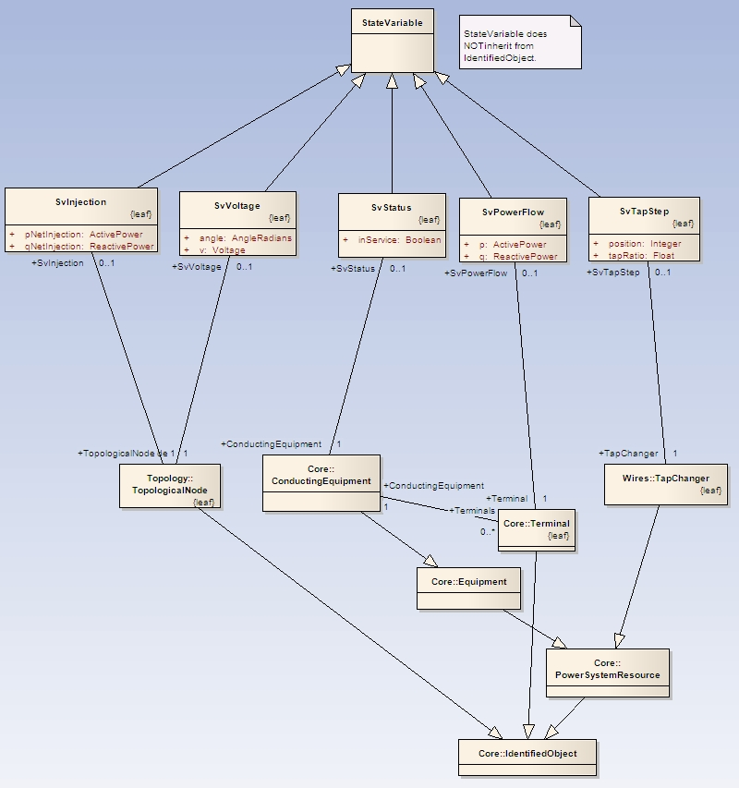

Analog and Status

We need to consider whether a profile is needed for analog measurement sets and for switch status values. Such a profile would be useful for exchanging input to a state estimator.

